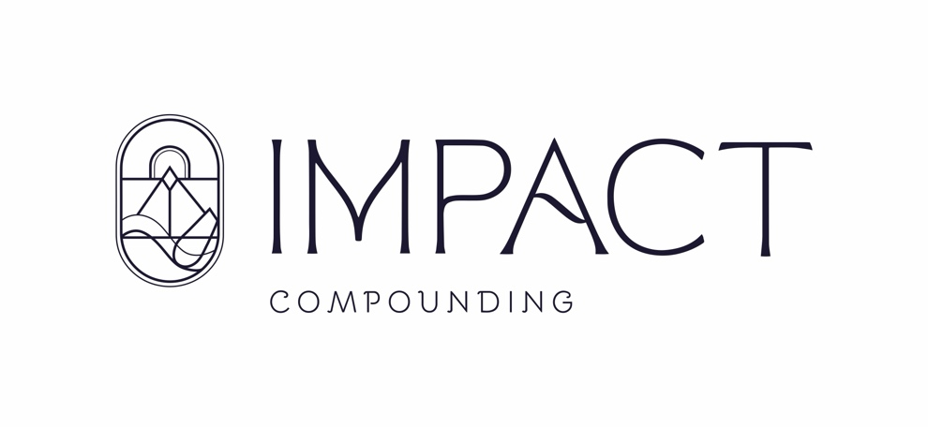

Supplement Guide
Order online anytime:
https://us.fullscript.com/welcome/impact-compounding
Prices In-Store & Online may vary slightly.

Stress & Sleep
Adapten-All 60 — Ortho Molecular — $34.80
Adapten-All 120 — Ortho Molecular — $61.10
Adrenevive 60 — Ortho Molecular — $57.30
Cortisol Manager 30 — Integrative Therapeutics — $25.75
Cortisol Manager 90 — Integrative Therapeutics — $68.50
L-Theanine 60 — Integrative Therapeutics — $21.99
Melatonin 60 — Pure Encapsulations — $15.50
NuAdapt 60 — Ortho Molecular — $60.50

Gut & Digestion
Colon Rx 60 — Designs for Health — $30.25
Digestive Enzymes — Pure Encapsulations — $36.20
Liver-GI Detox 120 — Pure Encapsulations — $62.00
Plant Enzyme Digestive — Integrative Therapeutics — $29.00

Hormone Support
Chrysin 500 — Ortho Molecular — $28.31
DHEA 25 — Ortho Molecular — $20.80
Pregnenolone — Ortho Molecular — $17.99
Saw Palmetto 320 — Pure Encapsulations — $89.50
Super MiraForte 120 — Life Extension — $62.99

Foundational Nutrients
Alpha Base 240 — Ortho Molecular — $58.00
Basic Prenatal — Thorne — $37.00
Basic Nutrients 2/Day — Thorne — $36.00
Iron Bisglycinate — Thorne — $16.00
Magnesium Glycinate 180 — Pure Encapsulations — $46.50
Magnesium Glycinate 240 — Pure Encapsulations — $55.00
O.N.E Multivitamin — Pure Encapsulations — $43.40
PureGenomics — Pure Encapsulations — $46.00
Reacted Magnesium — Ortho Molecular — $32.10
Vitamin D/K2 — Ortho Molecular — $28.00
Zinc 30 — Pure Encapsulations — $16.00
Selenium — Thorne — $14.00

Cardio & Metabolic
Bergamot BPF — Ortho Molecular — $51.30
OrthoOmega 820 120 — Ortho Molecular — $68.10
Super EPA — Thorne — $41.00

Immune
OrthoMune 120 — Ortho Molecular — $51.70

Bone & Joint
OsteoPrev 120 — Ortho Molecular — $68.90

Probiotics
FloraMend Prime — Thorne — $56.00
HU58 — Microbiome Labs — $50.32
MegaSporeBiotic — Microbiome Labs — $63.99
OrthoBiotic — Ortho Molecular — $36.99

Specialty
BPC-157 Delayed — Integrative Peptides — $109.99
MitoCore 120 — Ortho Molecular — $69.30
MegaQuinone — Microbiome Labs — $52.63
Resveratrol Supreme — Designs for Health — $58.90
Phosphatidylserine — Integrative Therapeutics — $48.25

Already left the pharmacy?
Sign up here: https://us.fullscript.com/welcome/impact-compounding or email kalbers@impactcompounding.com for the direct ordering link and free shipping over $50.

