

**Vaginal Troche Application & Guidelines**

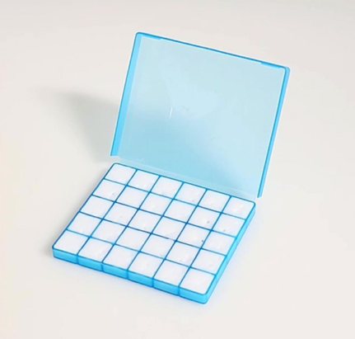

**Directions:**

* Remove the troche from the mold. Your directions will state if you are using a whole troche, ½ troche, etc.
* If using the supplied applicator, insert the troche into the open end of the applicator.
* Gently insert the applicator into the vaginal canal.
* Vaginal troches are best to be used at night. It is recommended to be mindful of the time you insert the troche, due to needing to avoid being intimate within the next 10 -12 hours after insertion.

**Storing your prescription:**

* Room temperature, in a cool, dry location. Avoid extreme temperatures and direct sunlight.
* Store troches in the container they were dispensed in as it contains dosage information.

Phone: (937) 761-2606

Fax: (937) 761-2607

info@impactcompounding.com

1920 Donn Davis Way

Tipp City, OH 45371

www.impactcompounding.com