
SYRINGES PRE-FILLED
WITH CREAM

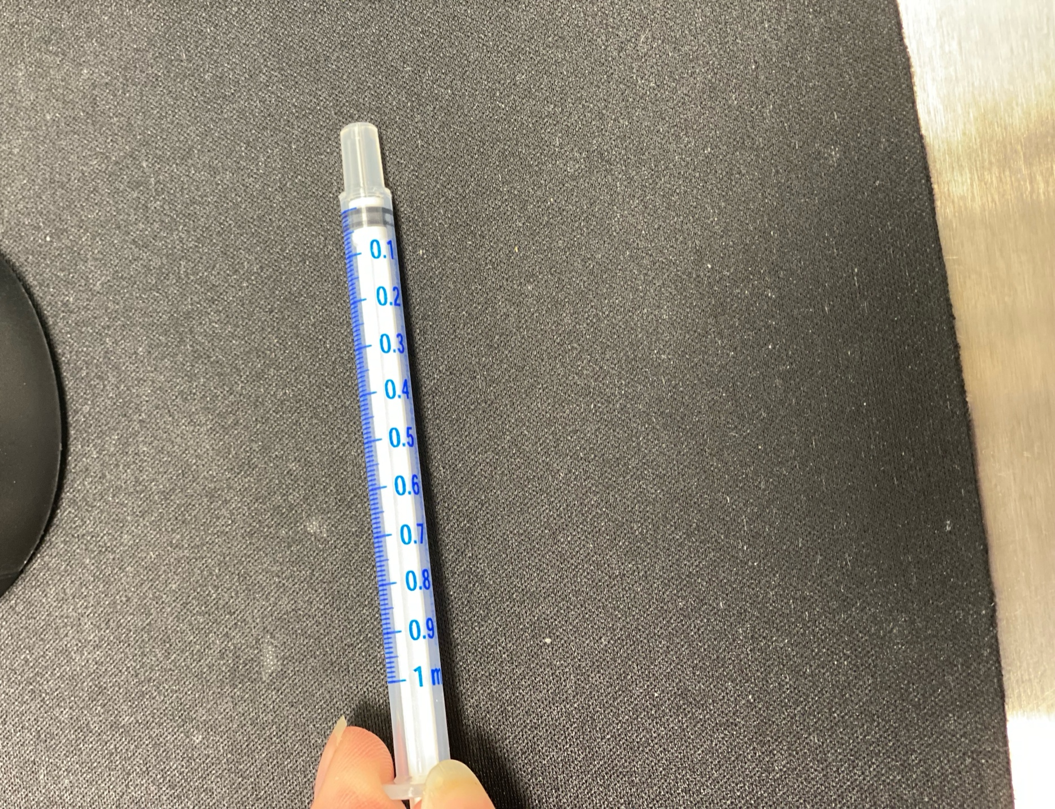
Directions:
Dispense directed amount of cream out of syringe (see image above our guidance) onto fingertip by gently pressing plunger.
Topical:
- Apply to application site as indicated on your prescription label.
Vaginal:
- Gently insert fingertip just inside vaginal canal, approximately ½”-1” depth. Gently apply cream to vaginal wall in a sweeping motion with fingertip.
- The vaginal wall acts like a ‘sponge’ and will readily absorb the hormone within the cream. You need not worry about ‘wasting’ the hormone through urination, wiping with tissue paper, or leakage.
- Vaginal cream can be applied day or night, but it is best used when you are least likely to be intimate within the next 10 hours. Always follow your prescriber’s instructions for application when indicated.
- Avoid sexual intercourse for 10-12 hours after application to prevent transference of hormone to your partner.
Storing your prescription:
- Syringes may be stored at room temperature, in a cool, dry location. Avoid extreme temperatures and direct sunlight.
- Store syringes in the baggie they were dispensed in as it contains dosage information.

Phone: (937) 761-2606
Fax: (937) 761-2607
info@impactcompounding.com

1920 Donn Davis Way
Tipp City, OH 45371
www.impactcompounding.com

